eCMS MANUAL

Registration and CFA Authorisation Approval

Department of Revenue and Customs
Ministry of Finance
Table of Contents
1. Introduction 2
2. Logging in as Custom Officer 2
3. Registration Approval 2
3.1 Search Application 3
3.2 Verifier 3
3.3 Approver 4
4. CFA Authorization Approval 5

Introduction
CMS use the Registration approval and Registration module to approve the application that has been submitted by applicant.

Logging in as Custom Officer
- The user needs to log into eCMS using the url: www.ecms.gov.bt
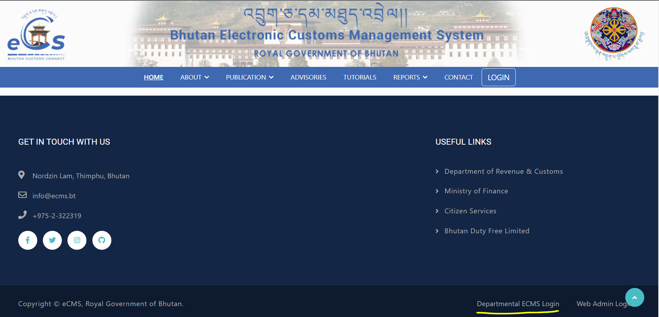
- Click on login menu and provide the required credentials to log in to the system:

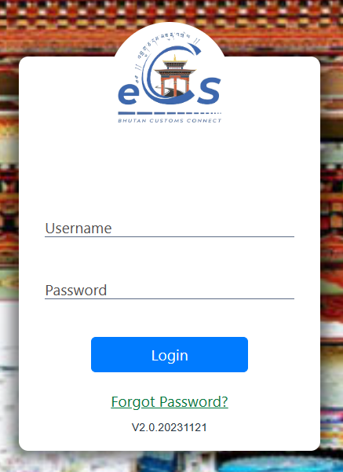

Registration Approval
The registration approval is to approve the registration applicant applied by the following:
- Trader
- Clearing and Forwarding Agent (CFA)
- Warehouse Operator (WHO)
- Temporary Storage (TSO)

- Click on the menu Registration Approval

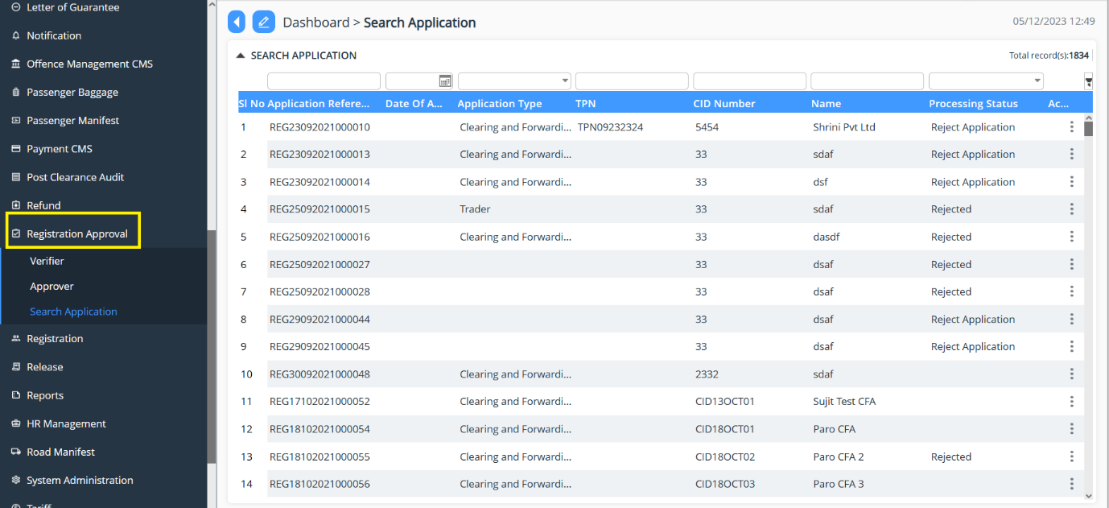

Search Application
- Go to Registration Application menu and click on “Search Application”.
- List of declaration that has been submitted and listed under the Custom user.
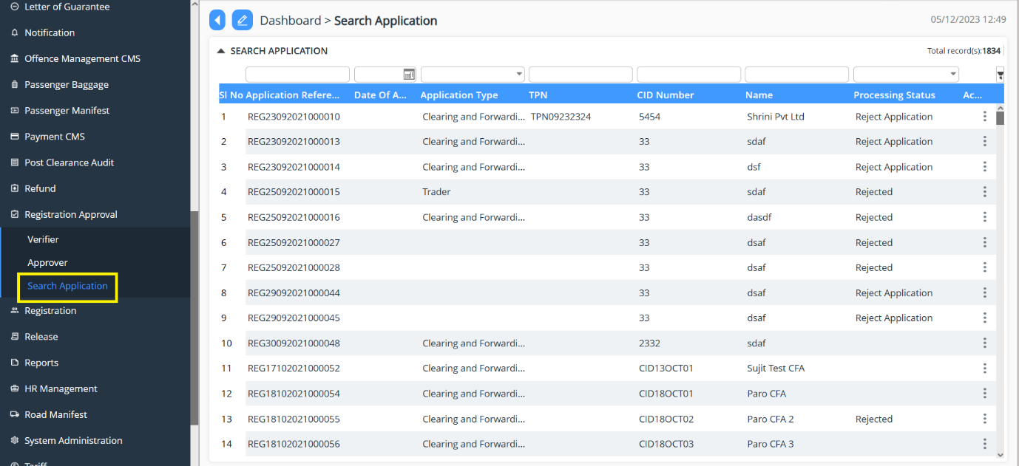

Verifier
- Go to Registration Approval menu and click on “Verifier”.
- Search for the application reference number if the number is known/ the Custom user will be doing there due diligent but working on the day-to-day application received.
- The Custom user will then validate the application under each menu to validate the detail submitted by the FE user.
- Once the review is completed the focal will have the option to do the following to the application:

- Recommend Approval: the application is reviewed the application and then recommend for the approval to next level.
- Reject Application: the application gets rejected due to certain reasons; the reason will be then provided in remarks.
- Send for amendment: due to certain missing details the application will be send back for amendment.
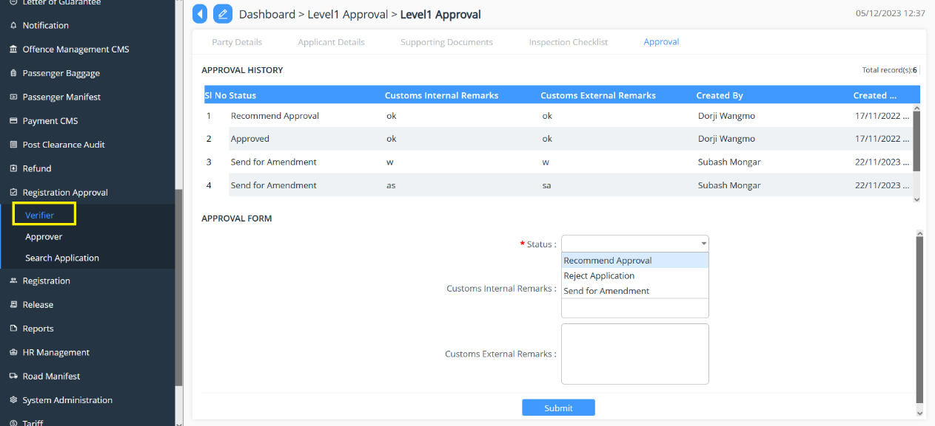

Approver
- Go to Registration Approval menu and click on “Approver”.
- Search for the application reference number if the number is known/ the Custom user will be doing there due diligent but working on the day-to-day application received.
- The Custom user will then validate the application under each menu to validate the detail submitted by the FE user.
- Once the review is completed the focal will have the option to do the following to the application:
- Approved: the recommended application via verifier is reviewed and approved
- Pending Re-review: the application gets rejected due to certain reasons; the reason will be then provided in remarks.
- Rejected: due to certain missing details the application will be send back for amendment.
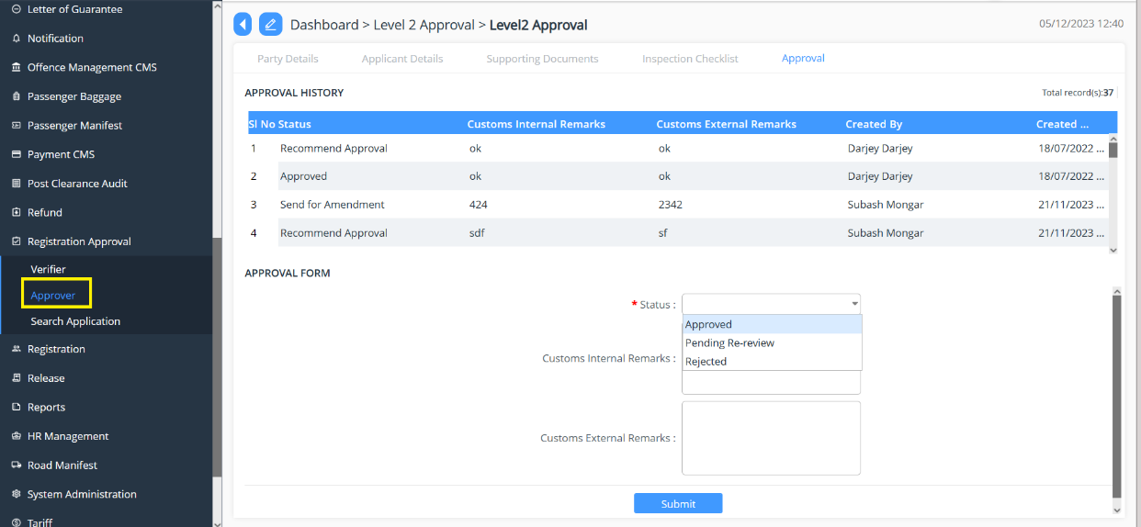

Note:
- Trader: the application related to the trader will be going through one stage approval, so the application will be populated under the Approver list under the tab Registration Approval
- For CFA, TSO and WHO: all the other goes through two stage of approval that is Verifier and Approver.

CFA Authorization Approval
- Click on the menu Registration and click on “CFA Authorisation”.
- List of application will be appeared in the dashboard.
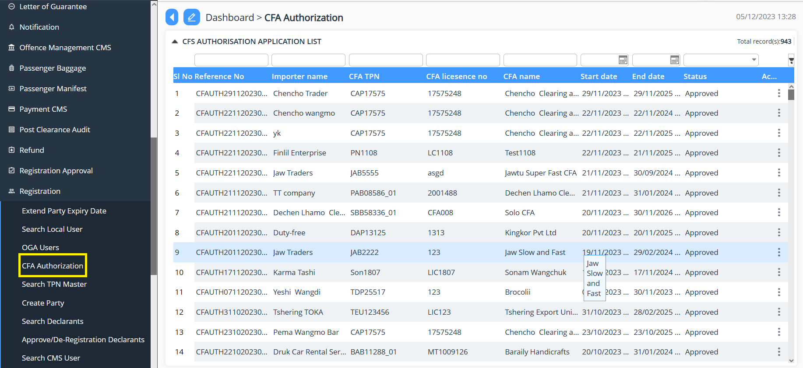
- Once the review is completed the focal will have the option to do the following to the application:
- Approved: the application is reviewed and approved
- Rejected: the application is rejected and remarks will be provided for rejection.

